* **RNN**

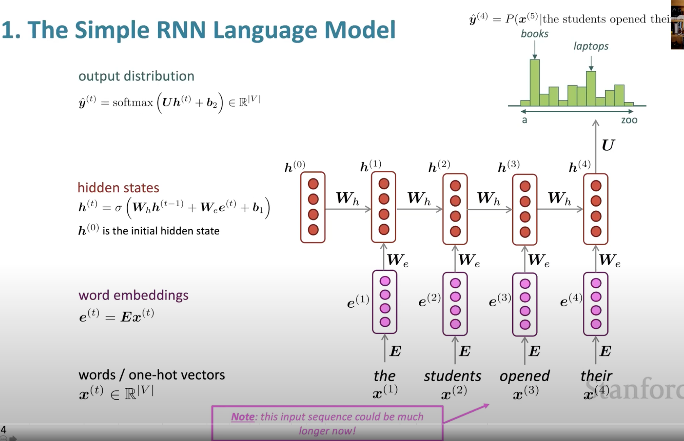

* **LSTM**

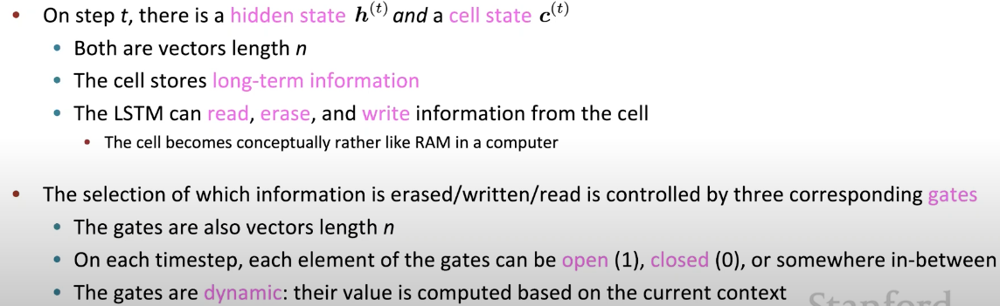

* An LSTM is similar to an RNN in that they both use hidden states to pass along information, but an LSTM also uses a cell state, which is like a long-term memory, to help deal with the issue of vanishing gradients
* An LSTM cell consists of a cell state, or long-term memory, a hidden state, or short-term memory, along with 3 gates that constantly update the relevancy of its inputs:
  + A **forget** gate, which decides which input units should be remembered and passed along. It's a tensor with values between 0 and 1.
    - If a unit has a value close to 0, the LSTM will "forget" the stored state in the previous cell state.
    - If it has a value close to 1, the LSTM will mostly remember the corresponding value.
  + An **update** gate, again a tensor containing values between 0 and 1. It decides on what information to throw away, and what new information to add.
    - When a unit in the update gate is close to 1, the value of its candidate is passed on to the hidden state.
    - When a unit in the update gate is close to 0, it's prevented from being passed onto the hidden state.
  + And an **output** gate, which decides what gets sent as the output of the time step

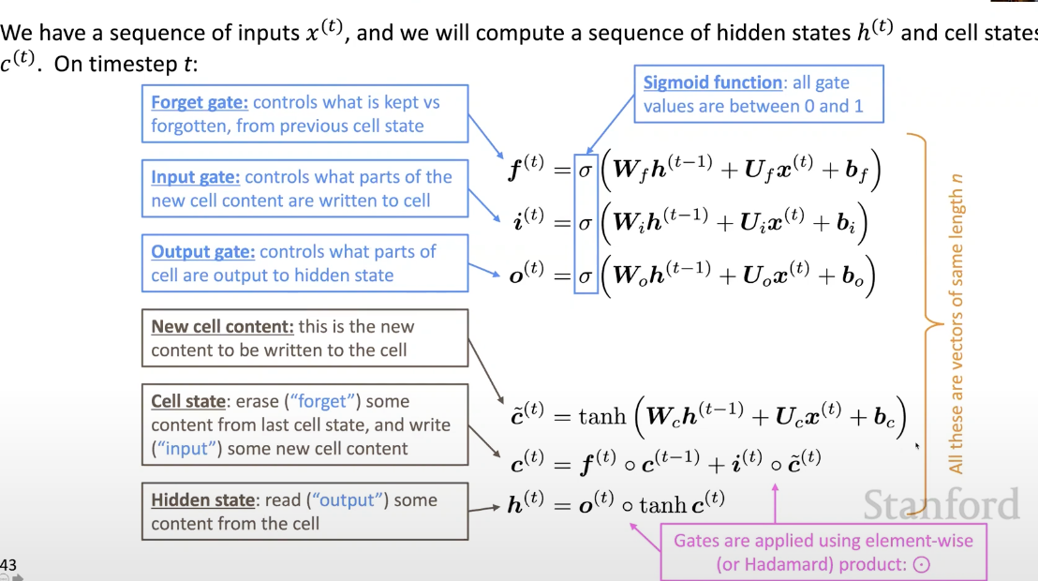

The prediction of classification for example, is **Y_pred = softmax(W_h@h_t + b_h)**

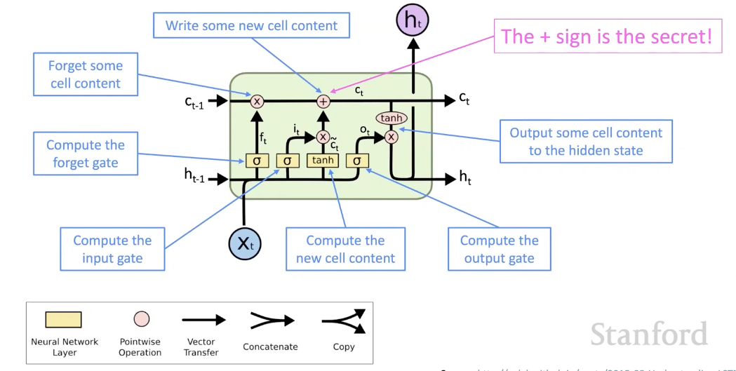

* **BIRDIRECTIONAL RNN (aka Elmo)**

In order to capture both ways of context

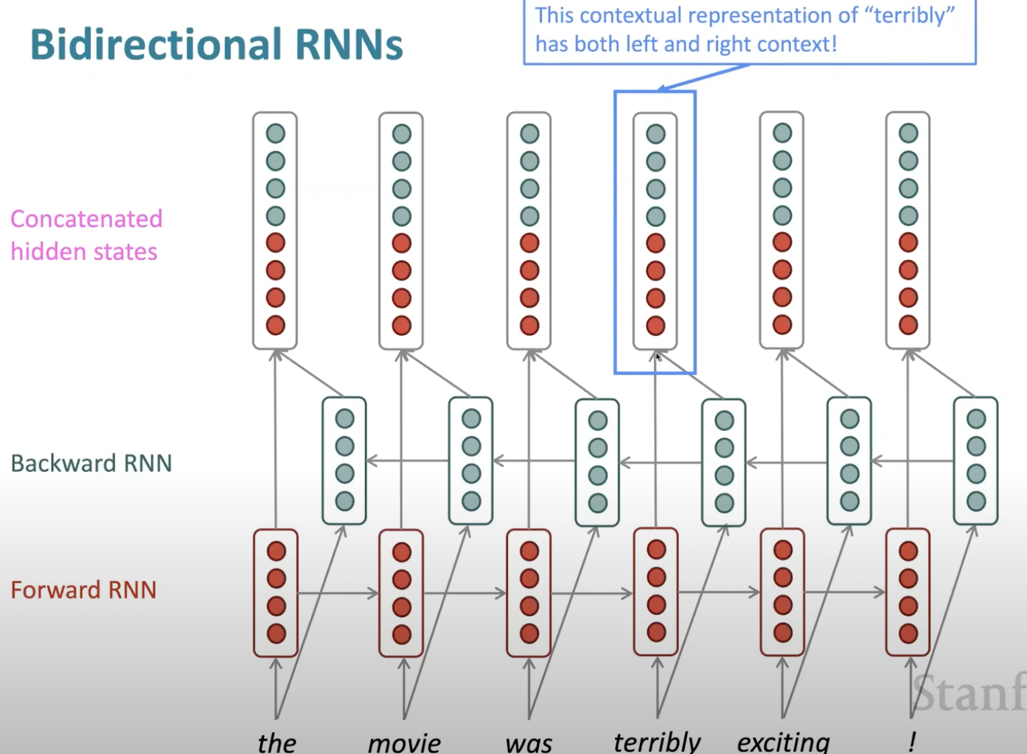

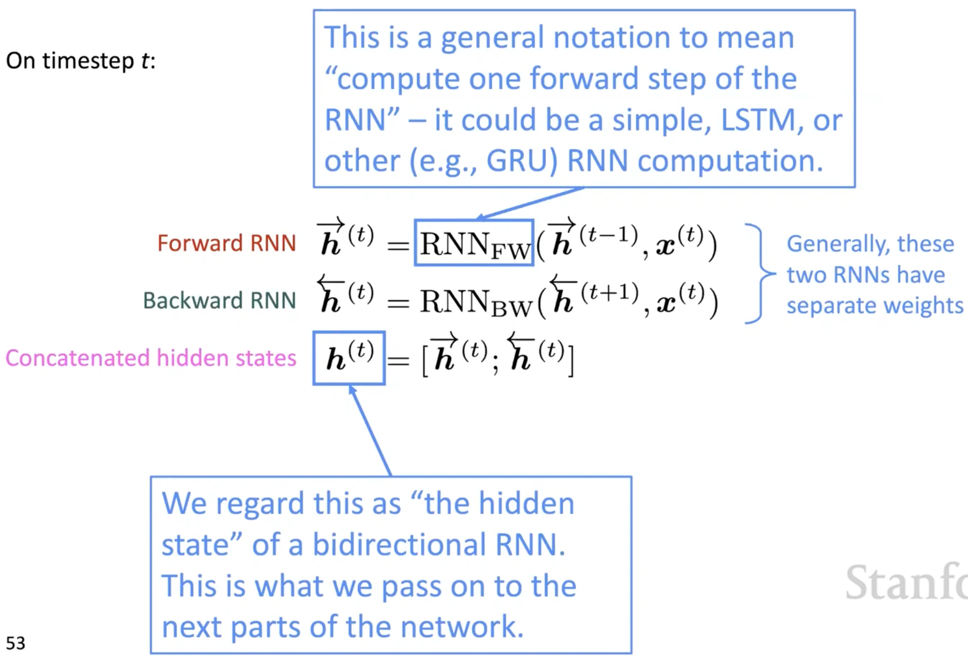

* **ENCODER DECODER**

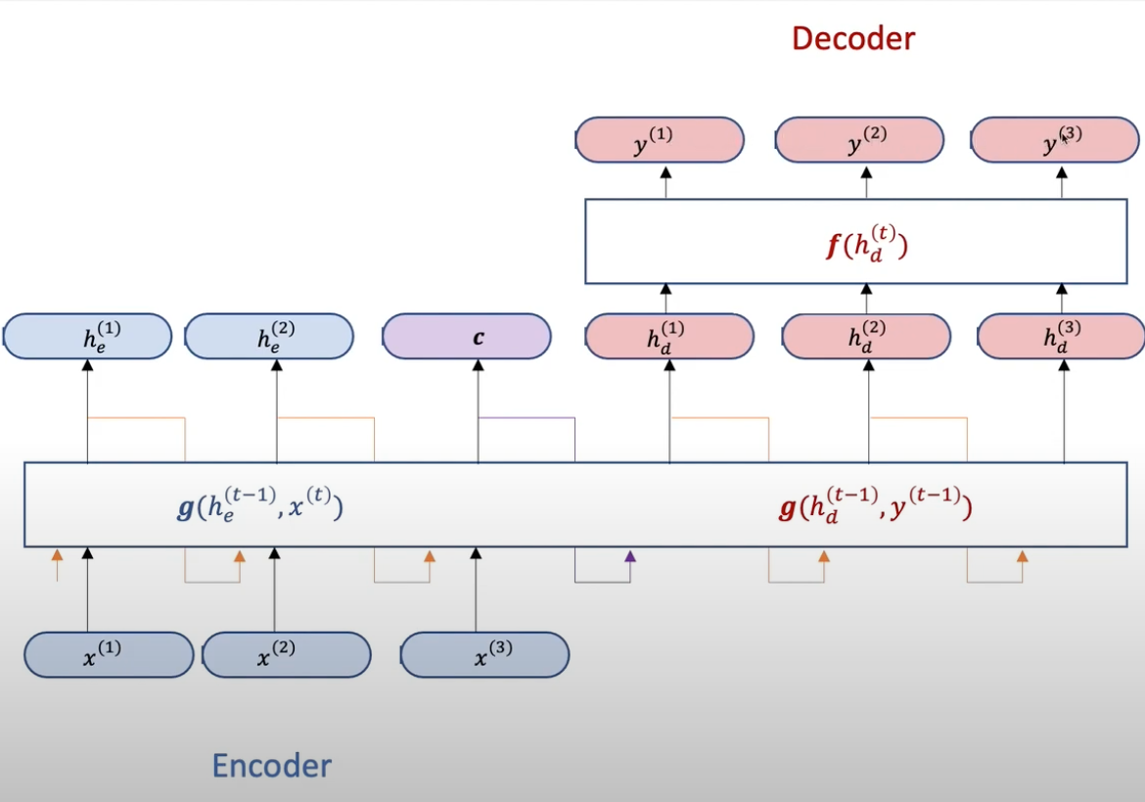

C is the final hidden state in encoder part, which captures all the info from previous hidden state in the sentence; decoder takes in C as the first hidden state, and a special token (i.e `<END>`) of the previous output as the current input, CWh + <END>Wx + b to predict y(1), it unrolls C.

* **[BEAM SEARCH](https://youtu.be/wzfWHP6SXxY)**

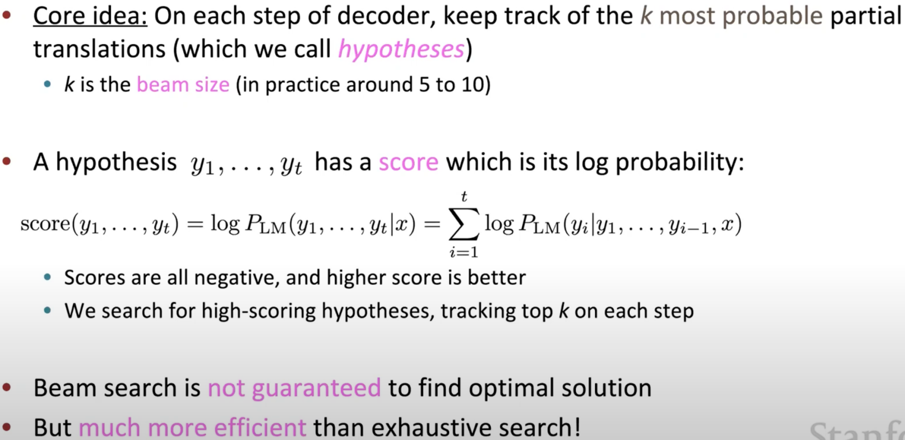

1. Stopping criterion

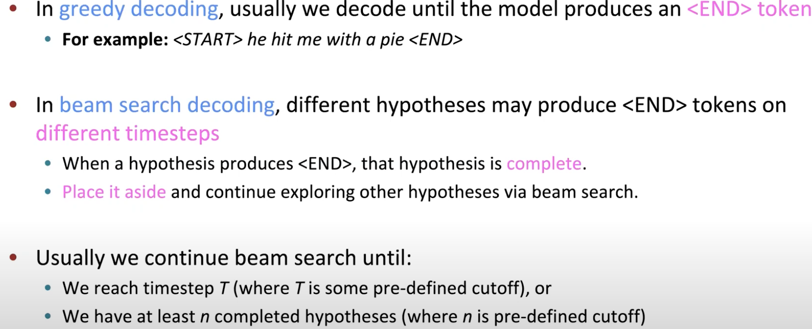

1. Problem

Longer sentences have lower score b/c accumulated multiplication



Fix: normalize be length, use this to select top one

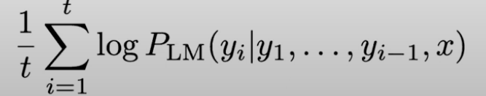

* **[ATTENTION](https://youtu.be/wzfWHP6SXxY)**

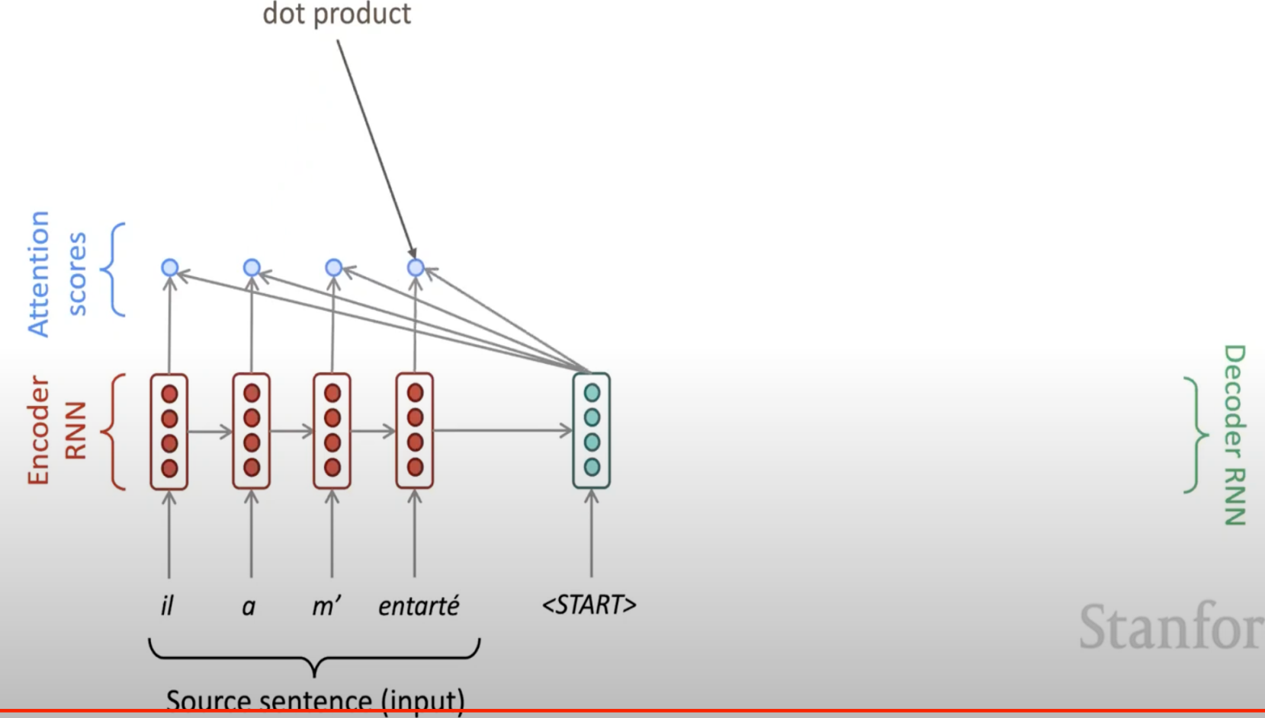

Find out which of the encoder state is most like the decoder state:

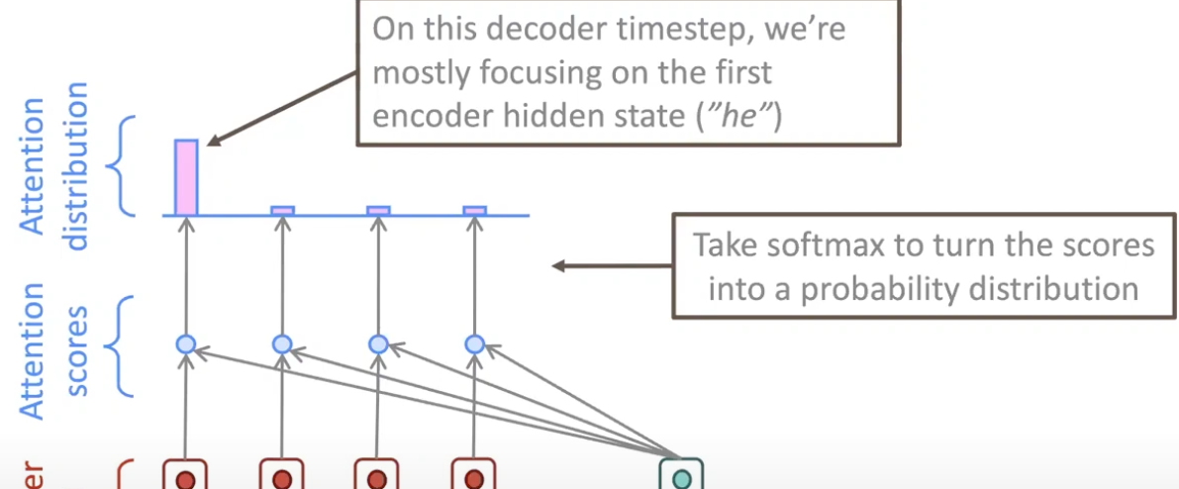

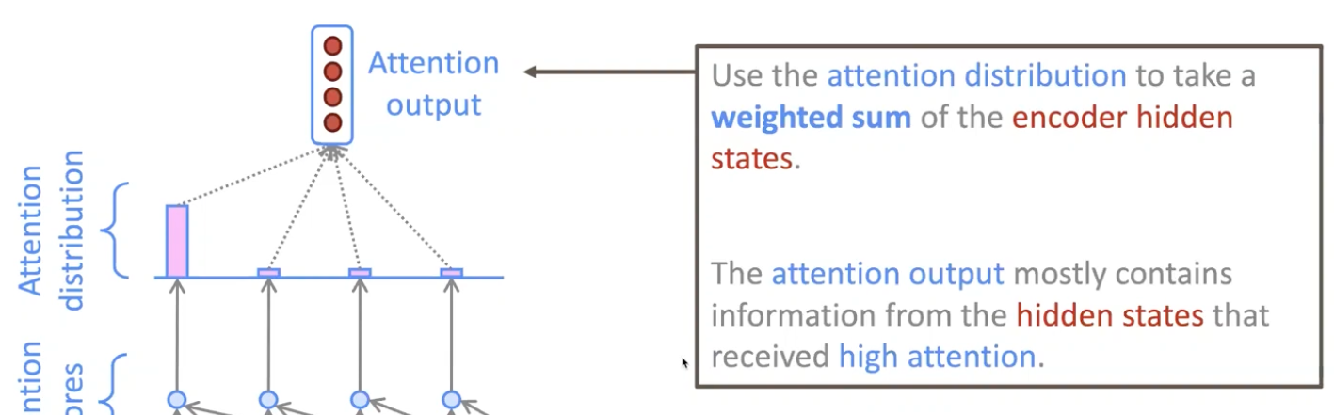

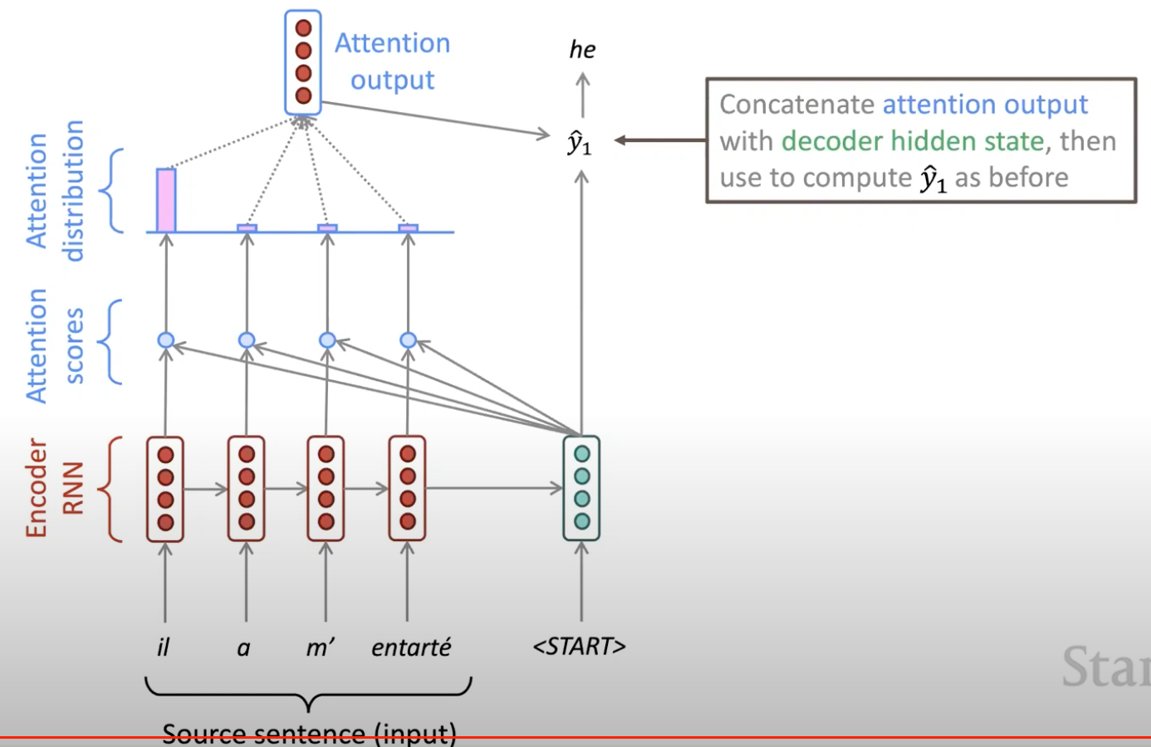

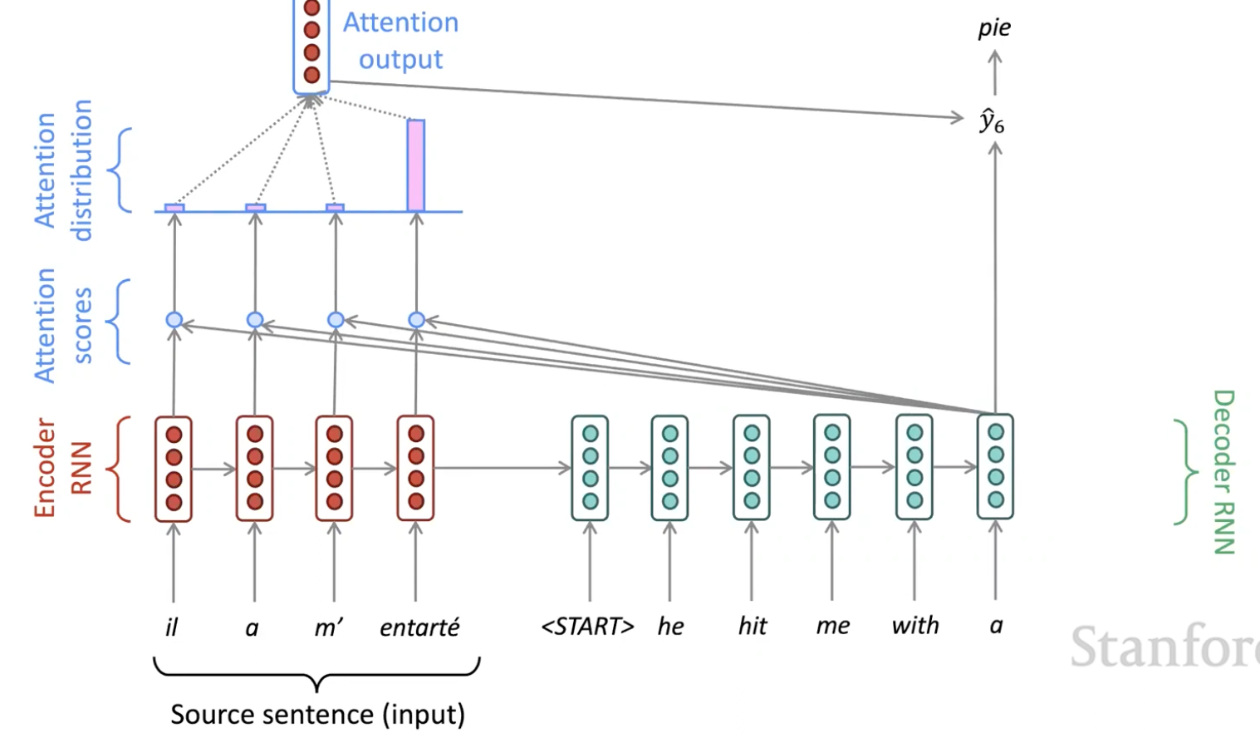

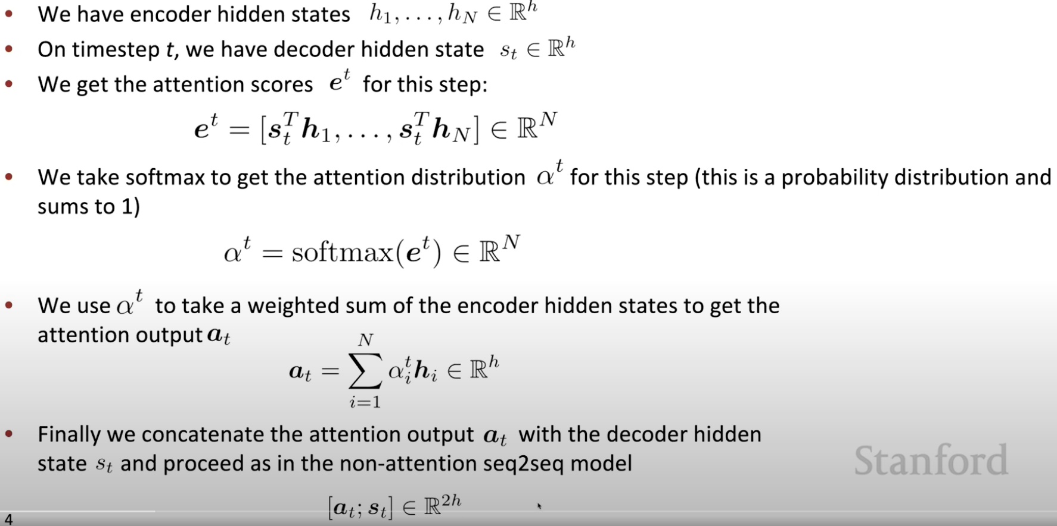

* **[TRANSFORMER](https://towardsdatascience.com/transformers-explained-visually-part-2-how-it-works-step-by-step-b49fa4a64f34)**

1. [Self-attention](https://youtu.be/ptuGllU5SQQ)

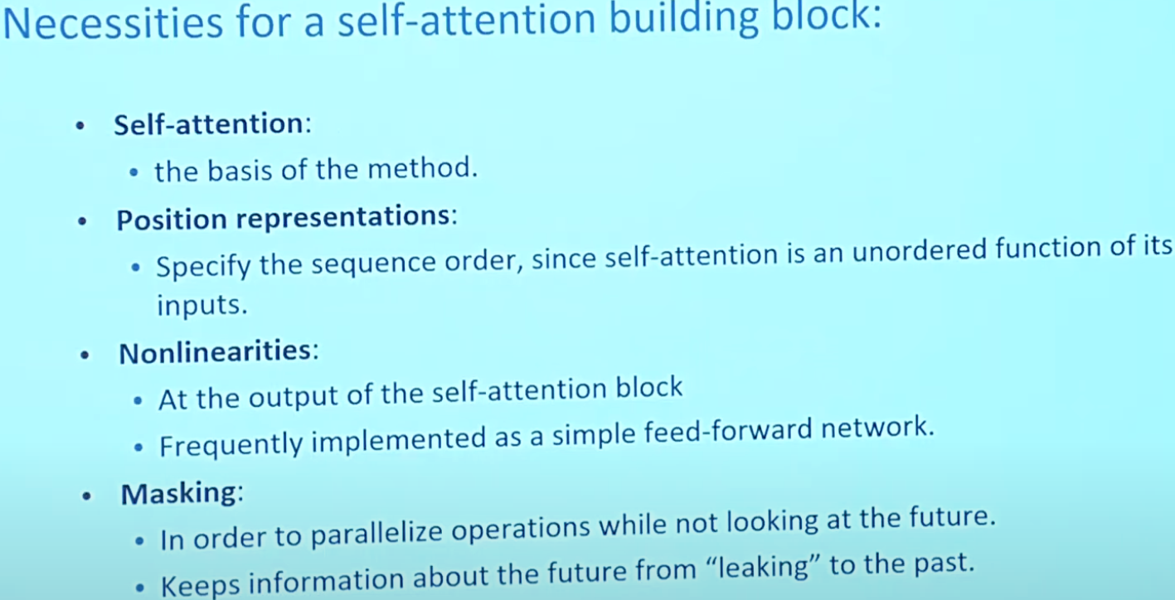

<https://towardsdatascience.com/transformers-explained-visually-not-just-how-but-why-they-work-so-well-d840bd61a9d3>

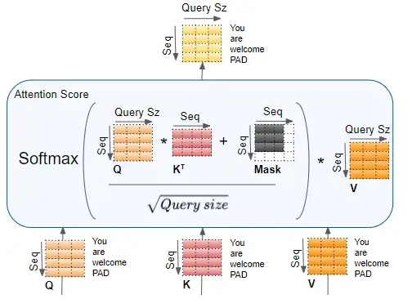

1. Multi-head attention

To look at a certain word’s interactions with different position in the sentence.

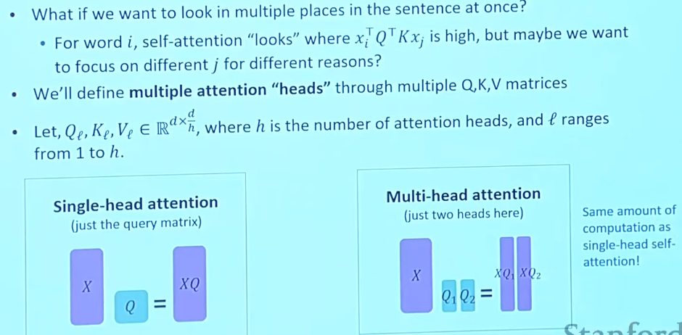

1. Transformer

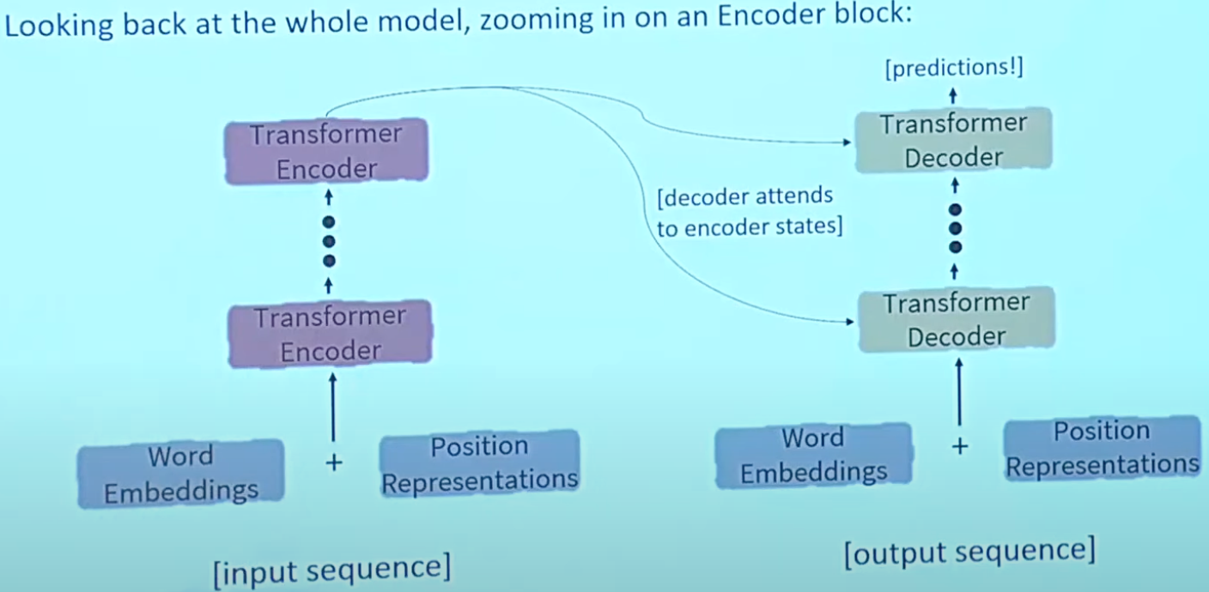

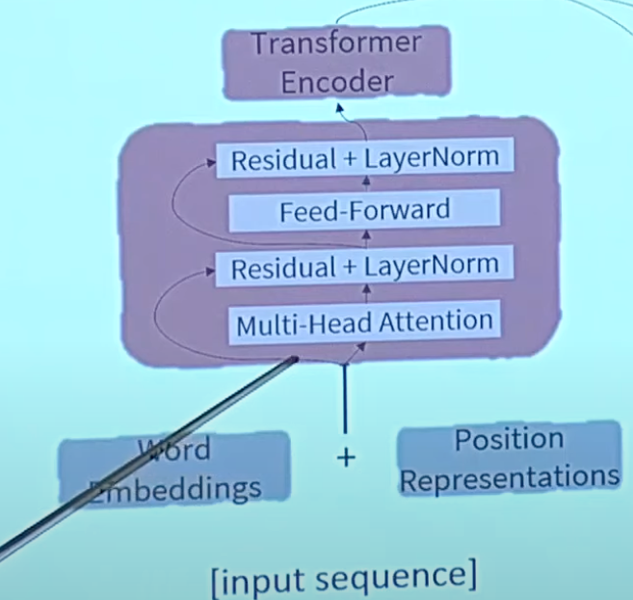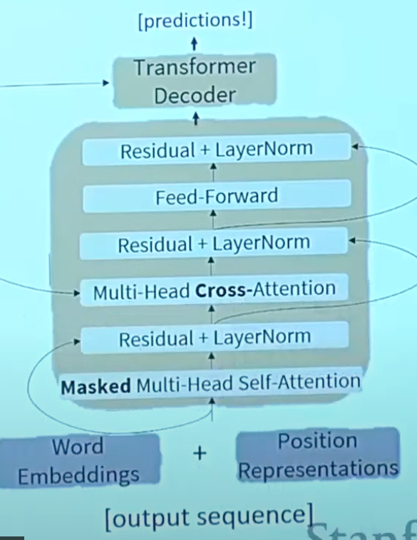

1. Pretraining

* **LEARNING WORDING EMBEDDING**

**Word2vec:**

1. Skip-grams

Learning context word’s embedding by predicting randomly chosen target word (within a window)

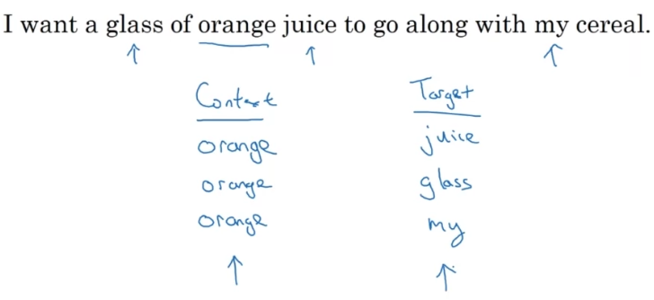

Problem: softmax needs probabilities of all the prediction first, very expensive

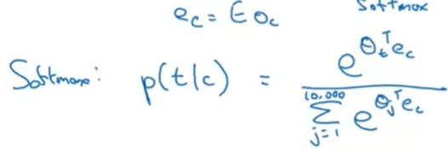

Theta_t is the parameters associate with the output t. what’s the probability t being the true label given context word

1. Cbow: using sounding few words(depends on window size) to predict the context word
2. Negative sampling

Give a pair of words, and predict if they are context-target pairs within a window(with true pair and randomly picked pairs).

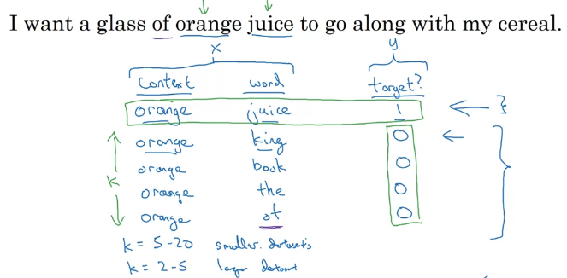

Instead of computing a softmax across the entire vocabulary, negative sampling computes binary-class classification across vocabulary, which is much cheaper

1. Glove

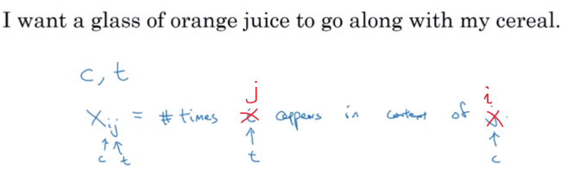

It captures how many times context and target words appear near each other (within a window size)